Recognized pattern: FakeDoc_variety1

The form of the pattern:

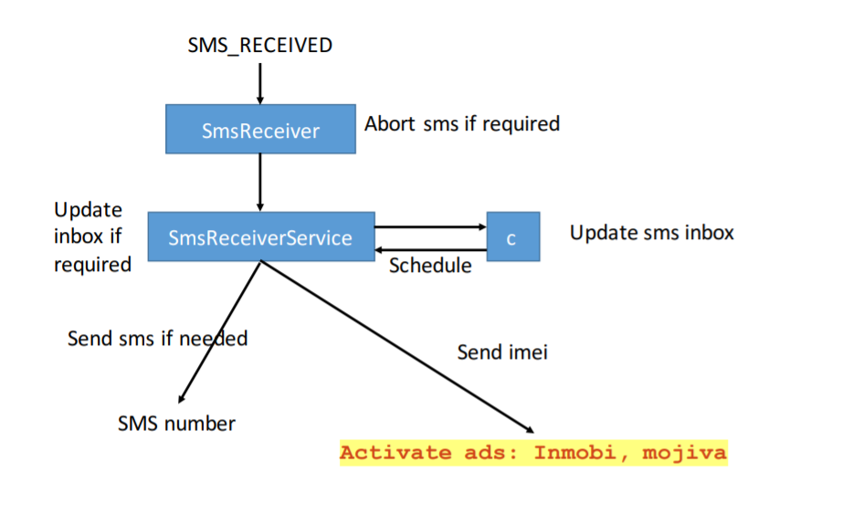

Name of Sample app: Battery SuperCharger

The name of this app: CrossWords

For functional modules:

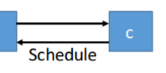

Corresponding to the key code in sample app:

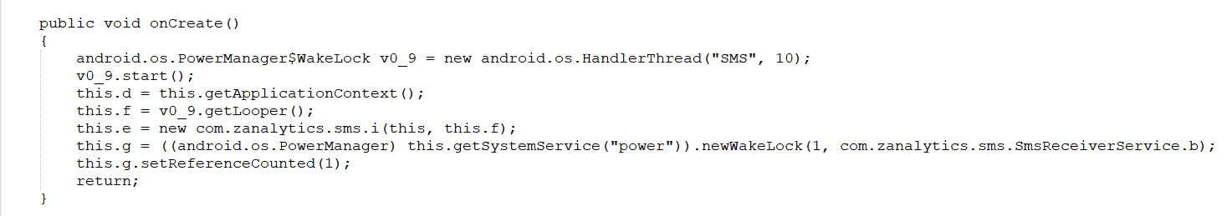

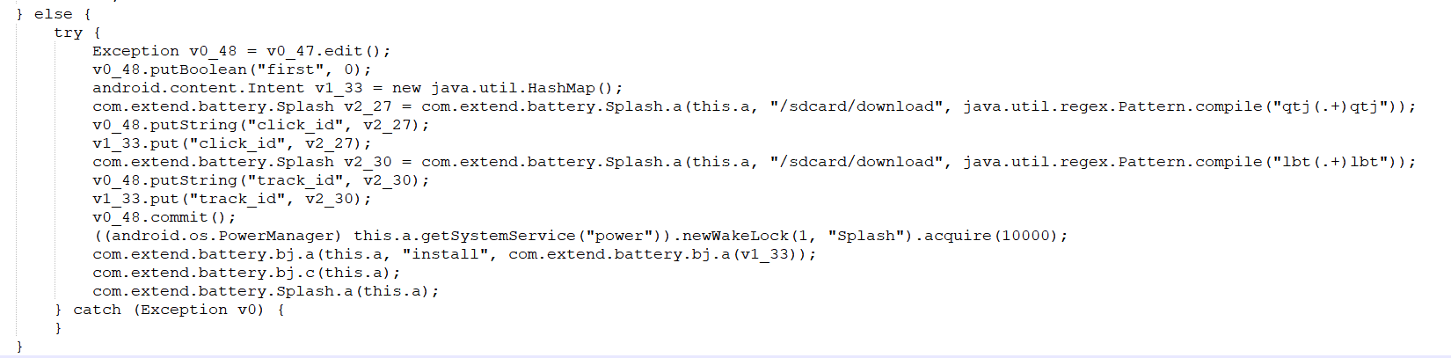

Corresponding to the key code in this app:

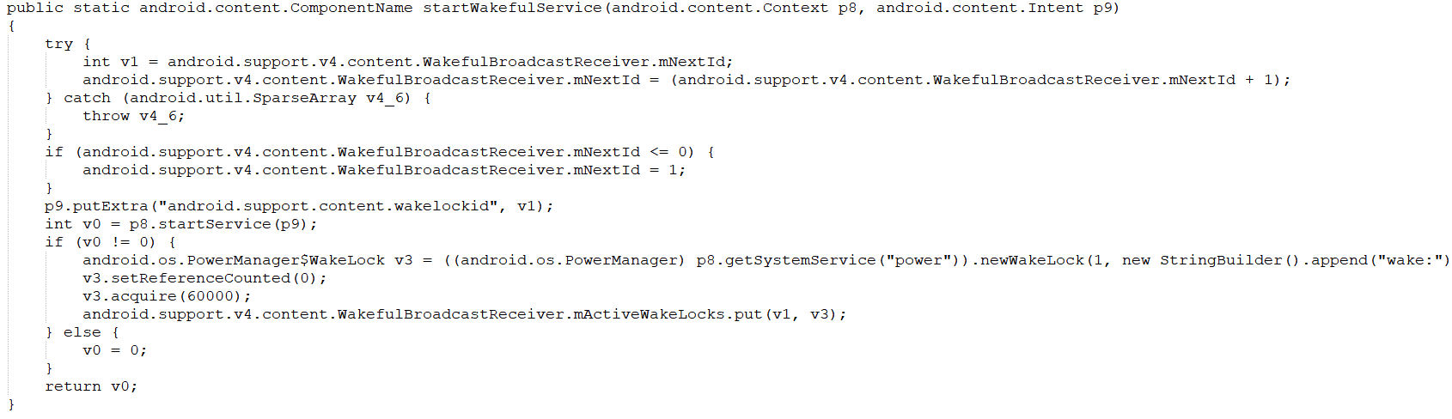

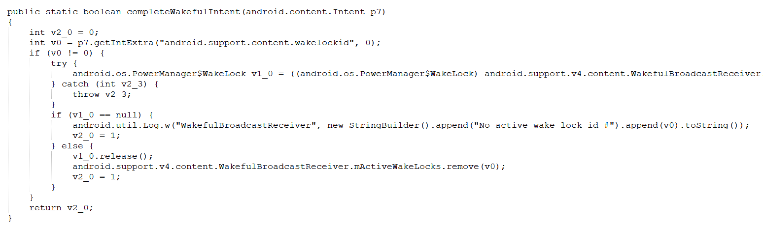

For functional modules:

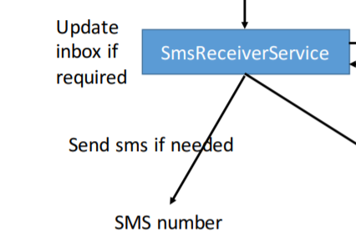

Corresponding to the key code in sample app:

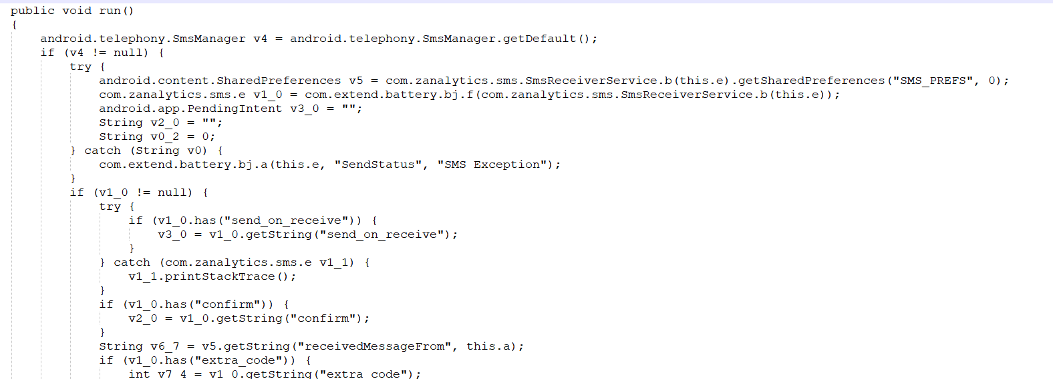

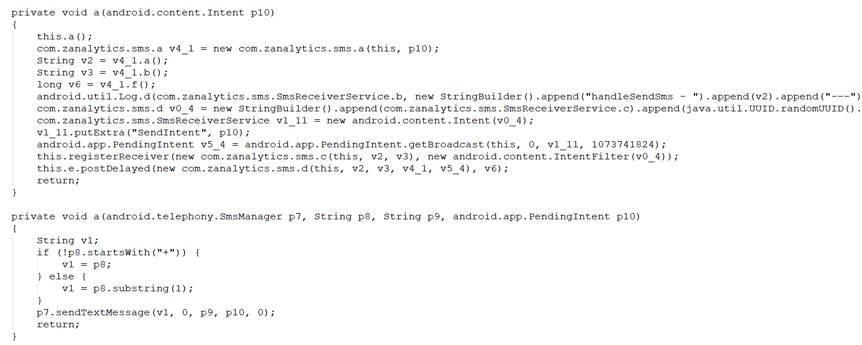

Corresponding to the key code in this app:

